1-Relational Model
# Source: AI Source: Provided by: [Data Path: Persons Table -> ID Column: 1, Name_En Column: Motasem Essam] -> From: [ChatGPT] on [6/10/2026]
The Relational Model is a way of structuring and managing data using tables (called relations) that was proposed by Dr. E.F. Codd in 1970. It's the foundation of relational databases like MySQL, PostgreSQL, and SQL Server.

🔹 What Is the Relational Model?
# Source: AI Source: Provided by: [Data Path: Persons Table -> ID Column: 1, Name_En Column: Motasem Essam] -> From: [ChatGPT] on [6/10/2026]
The relational model organizes data into tables (relations). Each table represents one entity type (e.g., customers, products) and consists of:
- Rows (tuples): Each row is a record.
- Columns (attributes): Each column is a field or property of the entity.

🔸 Example Table: Customers
# Source: AI Source: Provided by: [Data Path: Persons Table -> ID Column: 1, Name_En Column: Motasem Essam] -> From: [ChatGPT] on [6/10/2026]
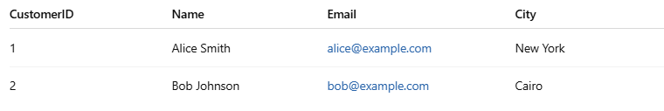
CustomerID | Name | Email | City
1 | Alice Smith | alice@example.com | New York
2 | Bob Johnson | bob@example.com | Cairo
- Table = Customers
- Row = One customer (e.g., Alice Smith)
- Column = One attribute (e.g., Name, City)

🔹 Key Concepts in the Relational Model
# Source: AI Source: Provided by: [Data Path: Persons Table -> ID Column: 1, Name_En Column: Motasem Essam] -> From: [ChatGPT] on [6/10/2026]
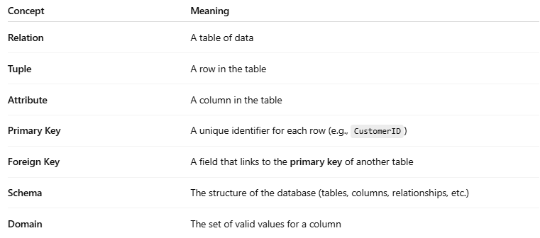
Concept | Meaning
Relation | A table of data
Tuple | A row in the table
Attribute | A column in the table
Primary Key | A unique identifier for each row (e.g., CustomerID)
Foreign Key | A field that links to the primary key of another table
Schema | The structure of the database (tables, columns, relationships, etc.)
Domain | The set of valid values for a column

🔹 Relationships Between Tables
# Source: AI Source: Provided by: [Data Path: Persons Table -> ID Column: 1, Name_En Column: Motasem Essam] -> From: [ChatGPT] on [6/10/2026]
The power of the relational model lies in how tables relate:
- One-to-One: One record in Table A matches one in Table B
- One-to-Many: One customer has many orders
- Many-to-Many: Students enrolled in many courses
✅ Keys and foreign keys enforce these relationships.

🔹 Example: Customer → Orders Relationship

Customers Table
# Source: AI Source: Provided by: [Data Path: Persons Table -> ID Column: 1, Name_En Column: Motasem Essam] -> From: [ChatGPT] on [6/10/2026]
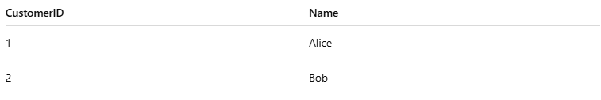
CustomerID | Name
1 | Alice
2 | Bob

Orders Table
# Source: AI Source: Provided by: [Data Path: Persons Table -> ID Column: 1, Name_En Column: Motasem Essam] -> From: [ChatGPT] on [6/10/2026]
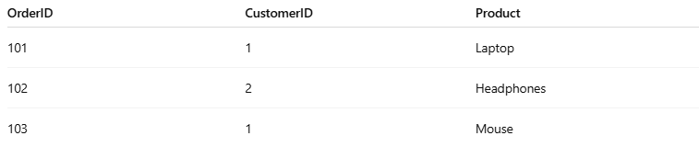
OrderID | CustomerID | Product
101 | 1 | Laptop
102 | 2 | Headphones
103 | 1 | Mouse
Here, CustomerID in Orders is a foreign key referencing the Customers table.

🔹 Why It’s Useful
# Source: AI Source: Provided by: [Data Path: Persons Table -> ID Column: 1, Name_En Column: Motasem Essam] -> From: [ChatGPT] on [6/10/2026]
- ✅ Data Integrity — Enforced by keys and constraints.
- ✅ Normalization — Avoids redundancy.
- ✅ Flexibility — Easy to query with SQL (e.g., JOINs).
- ✅ Scalability — Works well for large systems.

🔹 key

🔑 What is a Key in SQL?
# Source: AI Source: Provided by: [Data Path: Persons Table -> ID Column: 1, Name_En Column: Motasem Essam] -> From: [ChatGPT] on [6/10/2026]
In SQL, a key is a field (or a combination of fields) used to uniquely identify records, maintain data integrity, and establish relationships between tables.

🧩 Types of Keys in SQL
# Source: AI Source: Provided by: [Data Path: Persons Table -> ID Column: 1, Name_En Column: Motasem Essam] -> From: [ChatGPT] on [6/10/2026]
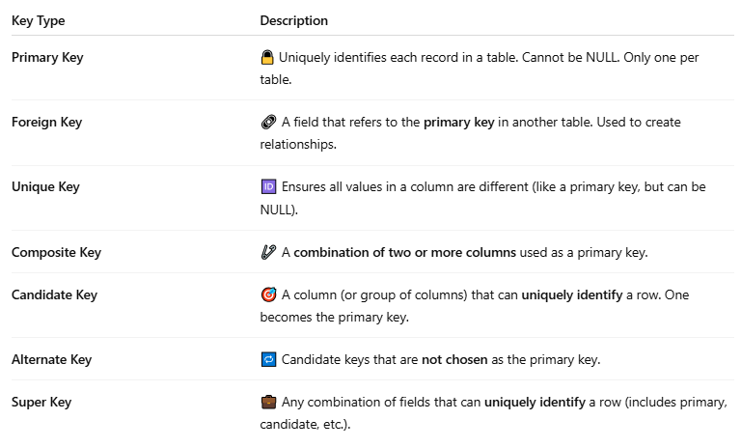
Key Type | Description
Primary Key | 🔒 Uniquely identifies each record in a table. Cannot be NULL. Only one per table.
Foreign Key | 🔗 A field that refers to the primary key in another table. Used to create relationships.
Unique Key | 🆔 Ensures all values in a column are different (like a primary key, but can be NULL).
Composite Key | 🧷 A combination of two or more columns used as a primary key.
Candidate Key | 🎯 A column (or group of columns) that can uniquely identify a row. One becomes the primary key.
Alternate Key | 🔁 Candidate keys that are not chosen as the primary key.
Super Key | 💼 Any combination of fields that can uniquely identify a row (includes primary, candidate, etc.).

Absolutely! Here are additional SQL key types with examples to reinforce understanding and cover real-world scenarios.

🔑 1. Primary Key
# Source: AI Source: Provided by: [Data Path: Persons Table -> ID Column: 1, Name_En Column: Motasem Essam] -> From: [ChatGPT] on [6/10/2026]
Ensures uniqueness of each row and cannot be NULL.
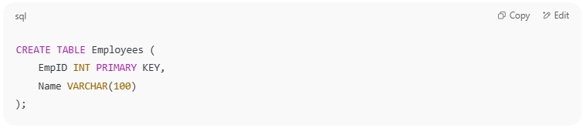
CREATE TABLE Employees (
EmpID INT PRIMARY KEY,
Name VARCHAR(100)
);

🧠 Use case: Identify each employee uniquely.

🔗 2. Foreign Key
# Source: AI Source: Provided by: [Data Path: Persons Table -> ID Column: 1, Name_En Column: Motasem Essam] -> From: [ChatGPT] on [6/10/2026]
Links to a primary key in another table to maintain referential integrity.
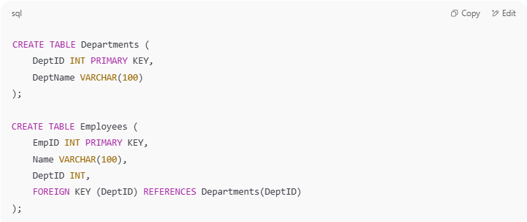
CREATE TABLE Departments (
DeptID INT PRIMARY KEY,
DeptName VARCHAR(100)
);

CREATE TABLE Employees (
EmpID INT PRIMARY KEY,
Name VARCHAR(100),
DeptID INT,
FOREIGN KEY (DeptID) REFERENCES Departments(DeptID)
);

🧠 Use case: Ensures each employee belongs to a valid department.

🆔 3. Unique Key
# Source: AI Source: Provided by: [Data Path: Persons Table -> ID Column: 1, Name_En Column: Motasem Essam] -> From: [ChatGPT] on [6/10/2026]
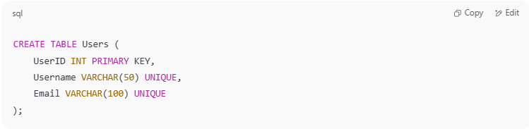
Ensures that all values in a column (or combo) are distinct.
CREATE TABLE Users (
UserID INT PRIMARY KEY,
Username VARCHAR(50) UNIQUE,
Email VARCHAR(100) UNIQUE
);

🧠 Use case: Prevents duplicate usernames or emails.

🧷 4. Composite (or Compound) Key
# Source: AI Source: Provided by: [Data Path: Persons Table -> ID Column: 1, Name_En Column: Motasem Essam] -> From: [ChatGPT] on [6/10/2026]
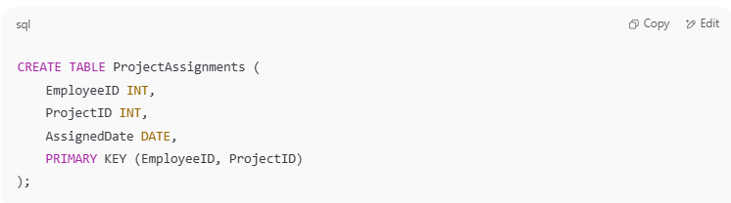
Combines multiple columns to form a primary or unique key.
CREATE TABLE ProjectAssignments (
EmployeeID INT,
ProjectID INT,
AssignedDate DATE,
PRIMARY KEY (EmployeeID, ProjectID)
);

🧠 Use case: Same employee can work on multiple projects but not the same one twice.

🎯 5. Candidate Key
# Source: AI Source: Provided by: [Data Path: Persons Table -> ID Column: 1, Name_En Column: Motasem Essam] -> From: [ChatGPT] on [6/10/2026]
Any column(s) that can serve as a primary key. The actual primary key is one of the candidate keys.

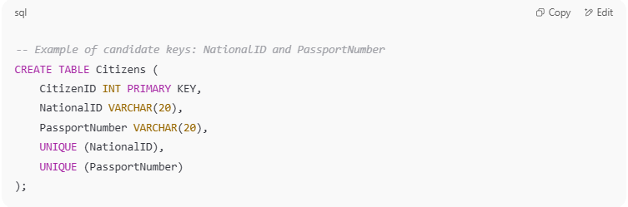
-- Example of candidate keys: NationalID and PassportNumber
CREATE TABLE Citizens (
CitizenID INT PRIMARY KEY,
NationalID VARCHAR(20),
PassportNumber VARCHAR(20),
UNIQUE (NationalID),
UNIQUE (PassportNumber)
);

🧠 Use case: Both NationalID and PassportNumber uniquely identify a citizen.

🔁 6. Alternate Key
# Source: AI Source: Provided by: [Data Path: Persons Table -> ID Column: 1, Name_En Column: Motasem Essam] -> From: [ChatGPT] on [6/10/2026]
A candidate key that is not chosen as the primary key.
From the previous example, if:
- CitizenID is the primary key,
- NationalID is an alternate key.

💼 7. Super Key
# Source: AI Source: Provided by: [Data Path: Persons Table -> ID Column: 1, Name_En Column: Motasem Essam] -> From: [ChatGPT] on [6/10/2026]

Any set of attributes that uniquely identify a row, including primary and candidate keys.
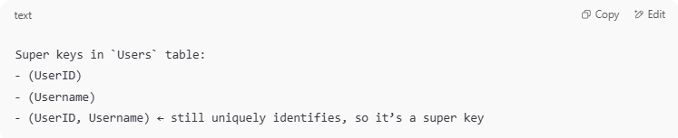
Super keys in `Users` table:
- (UserID)
- (Username)
- (UserID, Username) ← still uniquely identifies, so it’s a super key

🧠 Use case: The concept used in database theory to find candidate keys.

Summary Table
# Source: AI Source: Provided by: [Data Path: Persons Table -> ID Column: 1, Name_En Column: Motasem Essam] -> From: [ChatGPT] on [6/10/2026]

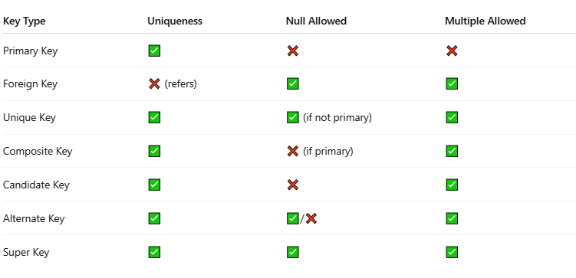
Key Type | Uniqueness | Null Allowed | Multiple Allowed
Primary Key | ✅ | ❌ | ❌
Foreign Key | ❌ (refers) | ✅ | ✅
Unique Key | ✅ | ✅ (if not primary) | ✅
Composite Key | ✅ | ❌ (if primary) | ✅
Candidate Key | ✅ | ❌ | ✅
Alternate Key | ✅ | ✅/❌ | ✅
Super Key | ✅ | ✅ | ✅

Would you like these keys inserted in test tables with data so you can try them practically in MySQL?

✅ Why Are Keys Important?
# Source: AI Source: Provided by: [Data Path: Persons Table -> ID Column: 1, Name_En Column: Motasem Essam] -> From: [ChatGPT] on [6/10/2026]
- 🔍 Help uniquely identify each row.
- 📊 Used for efficient searching and indexing.
- 🔗 Enforce relationships between tables.
- 🛡️ Maintain data integrity and prevent duplicates.
Would you like a diagram or sample dataset to test keys practically?

🔹 Table Relationship

🔗 What is a Table Relationship in SQL?
# Source: AI Source: Provided by: [Data Path: Persons Table -> ID Column: 1, Name_En Column: Motasem Essam] -> From: [ChatGPT] on [6/10/2026]
A table relationship in SQL refers to how two or more tables are logically connected using keys—primarily primary keys and foreign keys. These relationships allow you to link data stored in different tables, enabling powerful and efficient data modeling.

🧩 Why Do We Use Table Relationships?
# Source: AI Source: Provided by: [Data Path: Persons Table -> ID Column: 1, Name_En Column: Motasem Essam] -> From: [ChatGPT] on [6/10/2026]
- ✅ To organize data into multiple tables (normalization)
- ✅ To avoid redundancy and duplication
- ✅ To enforce data integrity
- ✅ To support complex queries with JOINs

🛠️ How Are Table Relationships Created?
# Source: AI Source: Provided by: [Data Path: Persons Table -> ID Column: 1, Name_En Column: Motasem Essam] -> From: [ChatGPT] on [6/10/2026]
Keys are essential:
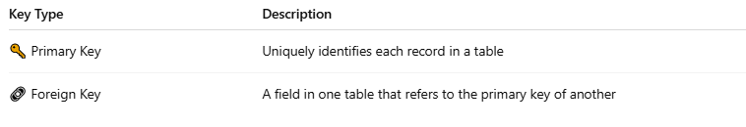
Key Type | Description
🔑 Primary Key | Uniquely identifies each record in a table
🔗 Foreign Key | A field in one table that refers to the primary key of another

🧪 Example:

🎯 1. Customers Table (parent)
# Source: AI Source: Provided by: [Data Path: Persons Table -> ID Column: 1, Name_En Column: Motasem Essam] -> From: [ChatGPT] on [6/10/2026]
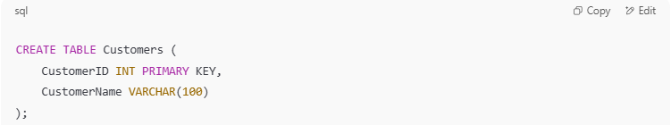
CREATE TABLE Customers (
CustomerID INT PRIMARY KEY,
CustomerName VARCHAR(100)
);

🧾 2. Orders Table (child)
# Source: AI Source: Provided by: [Data Path: Persons Table -> ID Column: 1, Name_En Column: Motasem Essam] -> From: [ChatGPT] on [6/10/2026]
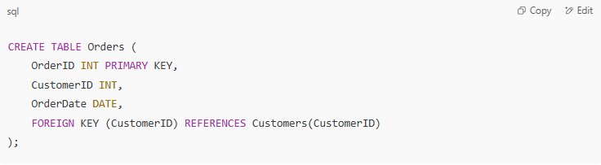
CREATE TABLE Orders (
OrderID INT PRIMARY KEY,
CustomerID INT,
OrderDate DATE,
FOREIGN KEY (CustomerID) REFERENCES Customers(CustomerID)
);

🔄 Meaning: Each order is related to one customer, and a customer can have multiple orders → One-to-Many relationship.

📊 Types of Table Relationships
# Source: AI Source: Provided by: [Data Path: Persons Table -> ID Column: 1, Name_En Column: Motasem Essam] -> From: [ChatGPT] on [6/10/2026]
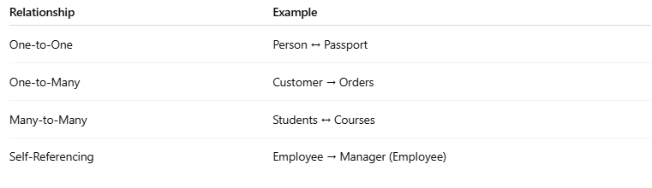
Relationship | Example
One-to-One | Person ↔ Passport
One-to-Many | Customer → Orders
Many-to-Many | Students ↔ Courses
Self-Referencing | Employee → Manager (Employee)

In SQL and database design, types of table relationships define how tables are logically connected based on the data they store. These relationships are crucial for organizing data efficiently and ensuring data integrity.

🧩 Types of Table Relationships
# Source: AI Source: Provided by: [Data Path: Persons Table -> ID Column: 1, Name_En Column: Motasem Essam] -> From: [ChatGPT] on [6/10/2026]
Relationship Type | Description
1️⃣ One-to-One (1:1) | A single row in Table A is related to one and only one row in Table B.
2️⃣ One-to-Many (1:N) | A single row in Table A can be related to many rows in Table B. Most common.
3️⃣ Many-to-Many (M:N) | Many rows in Table A can relate to many rows in Table B. Requires a junction table.
4️⃣ Self-Referencing | A table relates to itself using a foreign key. Often used for hierarchies.

🔍 1. One-to-One (1:1)
# Source: AI Source: Provided by: [Data Path: Persons Table -> ID Column: 1, Name_En Column: Motasem Essam] -> From: [ChatGPT] on [6/10/2026]
Example: Users and UserProfiles (separate table for optional profile data)
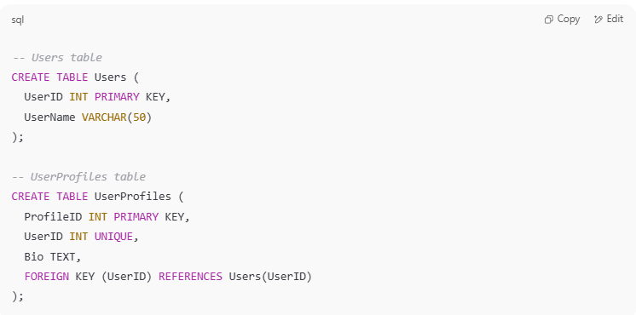
-- Users table
CREATE TABLE Users (
UserID INT PRIMARY KEY,
UserName VARCHAR(50)
);

-- UserProfiles table
CREATE TABLE UserProfiles (
ProfileID INT PRIMARY KEY,
UserID INT UNIQUE,
Bio TEXT,
FOREIGN KEY (UserID) REFERENCES Users(UserID)
);

🔍 2. One-to-Many (1:N)
# Source: AI Source: Provided by: [Data Path: Persons Table -> ID Column: 1, Name_En Column: Motasem Essam] -> From: [ChatGPT] on [6/10/2026]
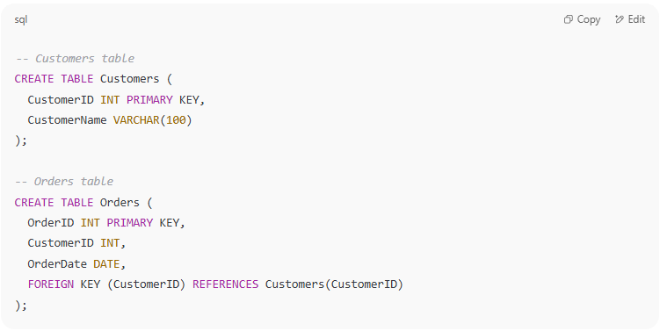
Example: One Customer can have many Orders
-- Customers table
CREATE TABLE Customers (
CustomerID INT PRIMARY KEY,
CustomerName VARCHAR(100)
);

-- Orders table
CREATE TABLE Orders (
OrderID INT PRIMARY KEY,
CustomerID INT,
OrderDate DATE,
FOREIGN KEY (CustomerID) REFERENCES Customers(CustomerID)
);

🔍 3. Many-to-Many (M:N)
# Source: AI Source: Provided by: [Data Path: Persons Table -> ID Column: 1, Name_En Column: Motasem Essam] -> From: [ChatGPT] on [6/10/2026]
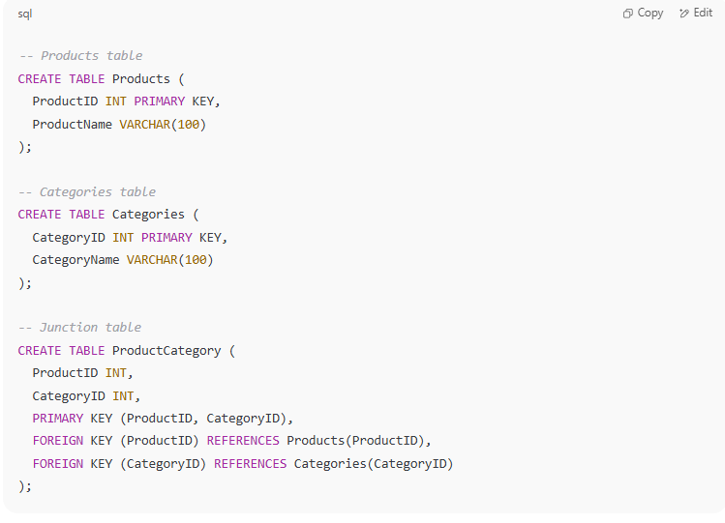
Example: Products and Categories (a product can belong to many categories and vice versa)
You need a junction (bridge) table:
-- Products table
CREATE TABLE Products (
ProductID INT PRIMARY KEY,
ProductName VARCHAR(100)
);

-- Categories table
CREATE TABLE Categories (
CategoryID INT PRIMARY KEY,
CategoryName VARCHAR(100)
);

-- Junction table
CREATE TABLE ProductCategory (
ProductID INT,
CategoryID INT,
PRIMARY KEY (ProductID, CategoryID),
FOREIGN KEY (ProductID) REFERENCES Products(ProductID),
FOREIGN KEY (CategoryID) REFERENCES Categories(CategoryID)
);

junction table

🔗 What is a Junction Table in SQL?
# Source: AI Source: Provided by: [Data Path: Persons Table -> ID Column: 1, Name_En Column: Motasem Essam] -> From: [ChatGPT] on [6/10/2026]
A junction table (also called a bridge table, link table, or associative entity) is a special table used to handle many-to-many (M:N) relationships between two other tables.

🧠 Why Is It Needed?
# Source: AI Source: Provided by: [Data Path: Persons Table -> ID Column: 1, Name_En Column: Motasem Essam] -> From: [ChatGPT] on [6/10/2026]
In SQL, you cannot directly create a many-to-many relationship between two tables. You must break it down into two one-to-many relationships using a junction table.

📊 Structure of a Junction Table
# Source: AI Source: Provided by: [Data Path: Persons Table -> ID Column: 1, Name_En Column: Motasem Essam] -> From: [ChatGPT] on [6/10/2026]
A junction table:
- Contains foreign keys from the two related tables.
- Often uses a composite primary key (made from both foreign keys).
- May contain additional columns (e.g., timestamps, roles, quantity).

🧪 Example: Products ↔ Categories
# Source: AI Source: Provided by: [Data Path: Persons Table -> ID Column: 1, Name_En Column: Motasem Essam] -> From: [ChatGPT] on [6/10/2026]
1. Products Table
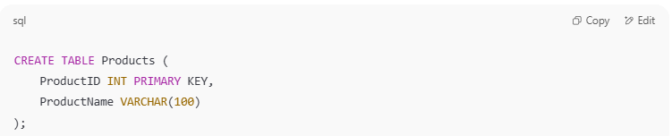
CREATE TABLE Products (
ProductID INT PRIMARY KEY,
ProductName VARCHAR(100)
);

2. Categories Table
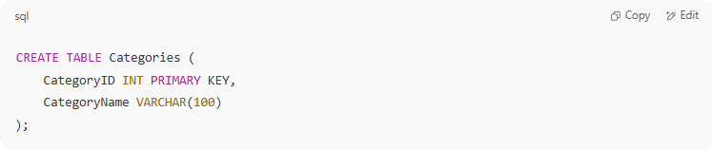
CREATE TABLE Categories (
CategoryID INT PRIMARY KEY,
CategoryName VARCHAR(100)
);

3. ProductCategory (Junction Table)
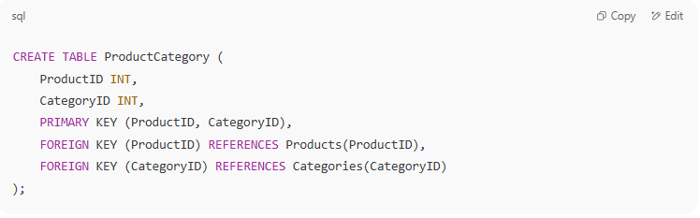
CREATE TABLE ProductCategory (
ProductID INT,
CategoryID INT,
PRIMARY KEY (ProductID, CategoryID),
FOREIGN KEY (ProductID) REFERENCES Products(ProductID),
FOREIGN KEY (CategoryID) REFERENCES Categories(CategoryID)
);

🔍 Use Case
# Source: AI Source: Provided by: [Data Path: Persons Table -> ID Column: 1, Name_En Column: Motasem Essam] -> From: [ChatGPT] on [6/10/2026]
- A product can belong to multiple categories.
- A category can have multiple products.
- The ProductCategory table links them and enables the many-to-many relationship.

📥 Inserting Data into a Junction Table
# Source: AI Source: Provided by: [Data Path: Persons Table -> ID Column: 1, Name_En Column: Motasem Essam] -> From: [ChatGPT] on [6/10/2026]
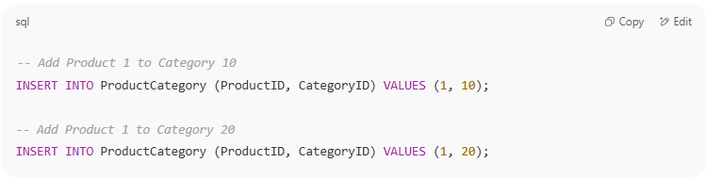
-- Add Product 1 to Category 10
INSERT INTO ProductCategory (ProductID, CategoryID) VALUES (1, 10);

-- Add Product 1 to Category 20
INSERT INTO ProductCategory (ProductID, CategoryID) VALUES (1, 20);

✅ Summary
# Source: AI Source: Provided by: [Data Path: Persons Table -> ID Column: 1, Name_En Column: Motasem Essam] -> From: [ChatGPT] on [6/10/2026]
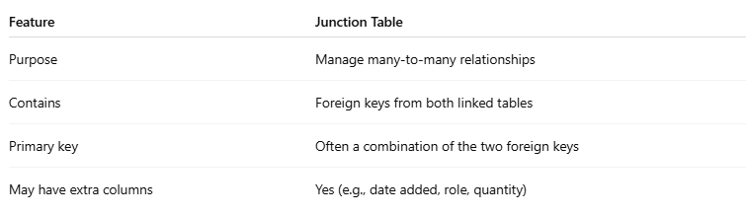
Feature | Junction Table
Purpose | Manage many-to-many relationships
Contains | Foreign keys from both linked tables
Primary key | Often a combination of the two foreign keys
May have extra columns | Yes (e.g., date added, role, quantity)

🔍 4. Self-Referencing (Recursive)
# Source: AI Source: Provided by: [Data Path: Persons Table -> ID Column: 1, Name_En Column: Motasem Essam] -> From: [ChatGPT] on [6/10/2026]
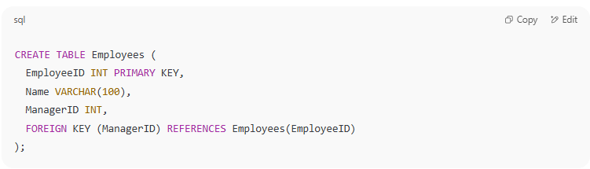
Example: Employees with managers (each employee may report to another employee)
CREATE TABLE Employees (
EmployeeID INT PRIMARY KEY,
Name VARCHAR(100),
ManagerID INT,
FOREIGN KEY (ManagerID) REFERENCES Employees(EmployeeID)
);

📌 Summary Table
# Source: AI Source: Provided by: [Data Path: Persons Table -> ID Column: 1, Name_En Column: Motasem Essam] -> From: [ChatGPT] on [6/10/2026]
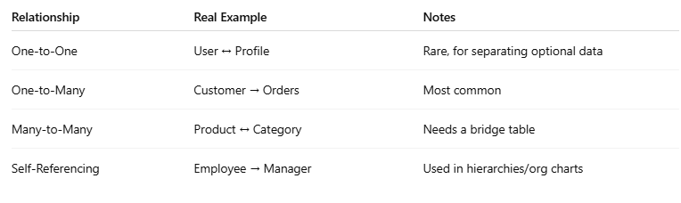
Relationship | Real Example | Notes
One-to-One | User ↔ Profile | Rare, for separating optional data
One-to-Many | Customer → Orders | Most common
Many-to-Many | Product ↔ Category | Needs a bridge table
Self-Referencing | Employee → Manager | Used in hierarchies/org charts

Would you like test data and queries for any of these relationships?

🔍 Used With
# Source: AI Source: Provided by: [Data Path: Persons Table -> ID Column: 1, Name_En Column: Motasem Essam] -> From: [ChatGPT] on [6/10/2026]
- FOREIGN KEY constraints
- JOIN queries to retrieve related data
- Referential integrity checks

